手机玻璃化学钢化炉
Mobile phone glass chemical tempering furnace
HGR1340
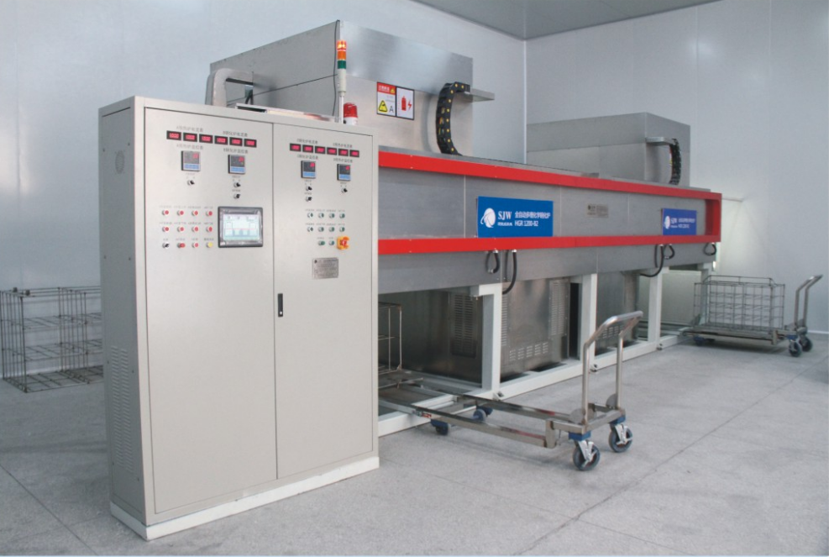

主要技术参数
Main technical parameters
设备组成 | Equipment Structure | 预热箱&冷却箱 2set + 钢化槽 1套  Preheating & cooling chamber 2sets  Toughening chamber 1sets
设备功率 | Equipment power | 110KW
高温循环风机 | High temperature circulating fan | 1.5KW
电热系统 | Electric heating system | PID+SCR控制  PID+SCR control
预热箱温控精度 | Temperature control accuracy of preheating chamber | ±5℃
钢化槽温控精度 | Temperature control accuracy of toughening chamber | ±2℃
硝酸钾 | Potassium Nitrate | 2.5 Ton
内胆尺寸 | Liner dimension | L1340*W980*H1100mm
吊篮尺寸 | Rack dimension | L1230*W780*H930mm
外形尺寸 | Overall dimension | L9400*W4200*H3800mm
设备重量 | Machine weight | 11000KG
产量 Output
玻璃尺寸  Glass size | 5.5inch | 7inch | 10inch | 12inch
参考产能  Output (cycle) | 5760 | 2560 | 1200 | 820
备注 ： 实际产能取决于客户的钢化炉时间和插片方式。表中产能仅供参考。
Note:
The actual capacity depends on the customer's toughening time and insert method.
The production capacity in the table is for reference only.

