We have following kinds of dental irigation needles:
(1)Disposable Dental Needle for Anesthesia Use:

Brand Name | WZ or OEM
Usage | Dental Anesthesia
Material | Medical Grade PP
Inner Diameter | 0.3mm,0.4mm
Needle Length | 16mm,21mm,25mm,30mm,32mm
Needle Size | 27G,30G
Color | 27G:Green  30G:Yellow
Disinfecting Type | EO Gas
Packing | Bulk+Medium Box Packaging
Certificate | CE,ISO
Lead Time | 40 days after payment
Supply Ability | 1000000 PCS/DAY
Payment Terms | 30% T/T in advance as for deposit, balance was paid before delivery or L/C at sight full payment
Warning | Single use only;Do not use if package is damaged.
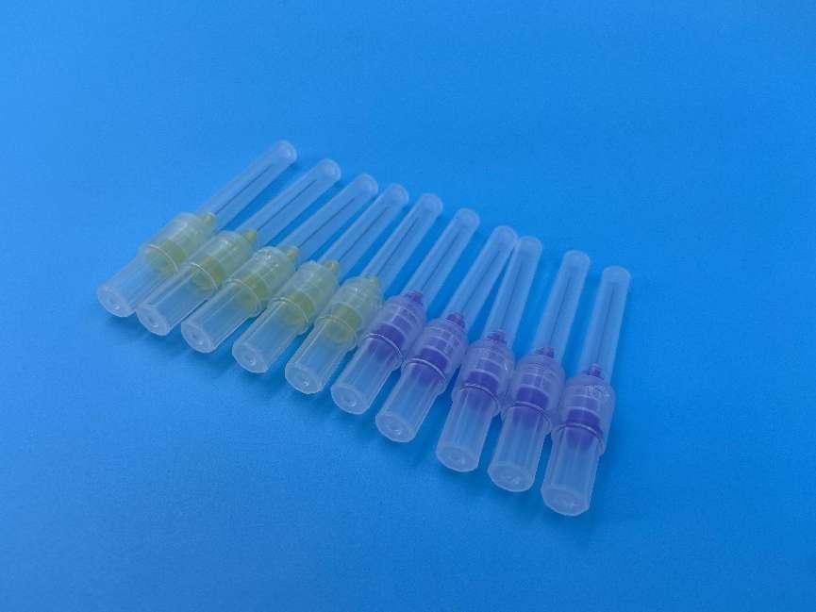

(2)Pre-bent Curved Irrigation Dental Needle:
Brand Name | WZ or OEM
Usage | Dentist Working Partner
Material | Plastic
Size | 18G,19G,20G,21G,22G,23G,24G,25G,27G
Needle Length | 13mm or 15mm
Needle | Medical 304 Stainless Steel,18-27G
Disinfecting Type | EO gas
Packing | Bulk+Medium Box Packaging
Certificate | CE,ISO
Lead Time | 40 days after payment
Supply Ability | 1000000 PCS/DAY
Payment Terms | 30% T/T in advance as for deposit, balance was paid before delivery or L/C at sight full payment .
Warning | Single use only;Do not use if package is damaged.
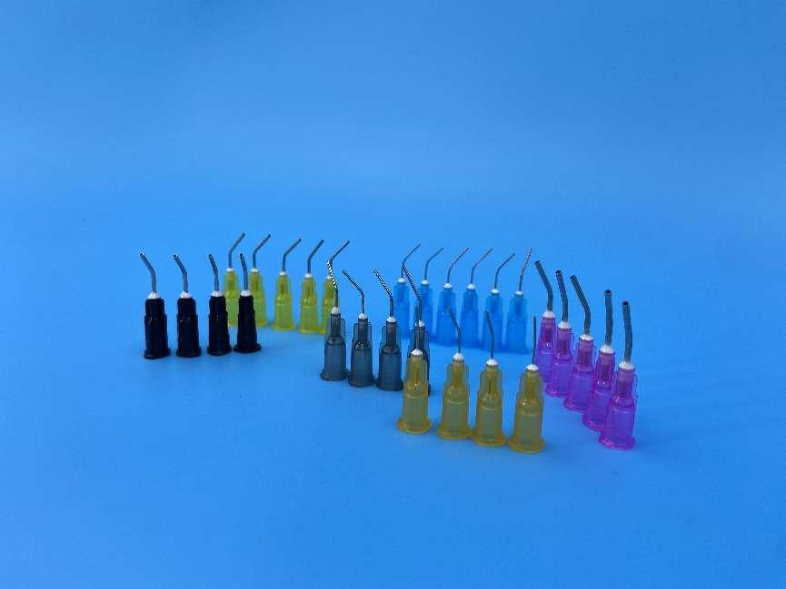

(3)Butterfly Curved Dental Needle:
Brand Name | WZ or OEM
Usage | Oral Surgery
Material | PP
Inner Diameter | 0.25mm,0.35mm,0.4mm
Color | Blue/Transparent
Disinfecting Type | EO Gas
Packing | Bulk+Medium Box Packaging
Certificate | CE,ISO
Lead Time | 40 days after payment
Supply Ability | 1000000 PCS/DAY
Payment Terms | 30% T/T in advance as for deposit, balance was paid before delivery or L/C at sight full payment .
Warning | Single use only;Do not use if package is damaged.
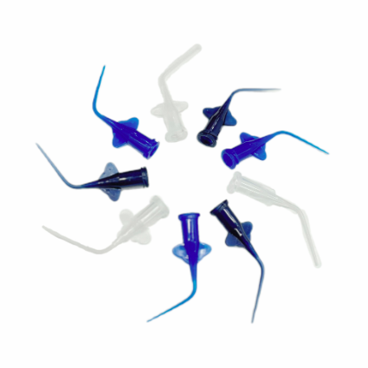

(4)Double or Single Vent Side Hole Dental Needle:
Brand Name | WZ or OEM
Usage | Dental Clinic
Material | Medical Grade PP
Inner Diameter | 0.3mm,0.4mm
Needle Length | 25mm
Needle Size | 27G,30G
Color | Yellow
Disinfecting Type | EO Gas
Packing | Bulk+Medium Box Packaging
Certificate | CE,ISO
Lead Time | 40 days after payment
Supply Ability | 1000000 PCS/DAY
Payment Terms | 30% T/T in advance as for deposit, balance was paid before delivery or L/C at sight full payment
Warning | Single use only;Do not use if package is damaged.
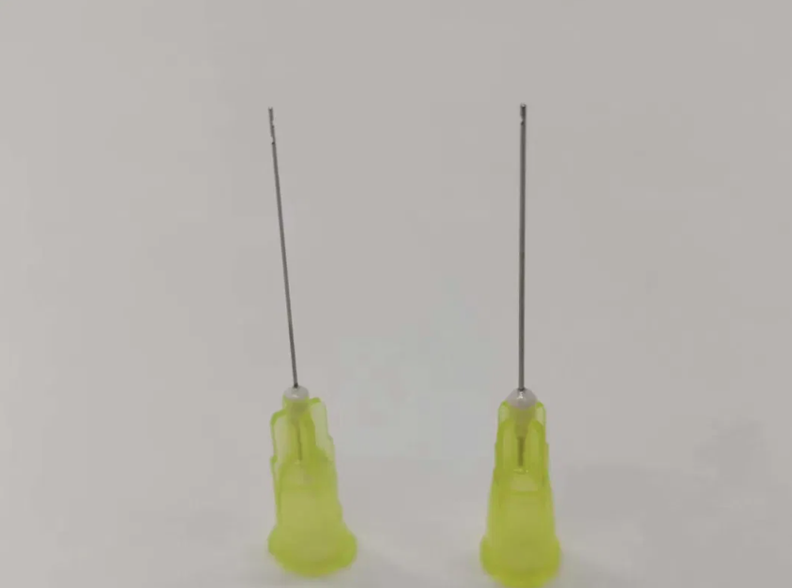
(5)Side Cut Dental Irrigation Needle:

Brand Name | Wuzhou or OEM
Usage | Dental Clinic
Material | Medical Grade PP
Inner Diameter | 0.4mm,0.6mm
Needle Length | 25mm
Needle Size | 23G
Color | Blue
Disinfecting Type | EO Gas
Packing | Bulk+Medium Box Packaging
Certificate | CE,ISO
Lead Time | 40 days after payment
Supply Ability | 1000000 PCS/DAY
Payment Terms | 30% T/T in advance as for deposit, balance was paid before delivery or L/C at sight full payment
Warning | Single use only;Do not use if package is damaged.
