Date:
Offer No:
OFFER
 | Company: | Responsible:
 | Tel: | Fax: |  | E-mail:
 | Address:
Ø50 HDPE MONO FILM MACHINE 600 MM
GENERAL SPECIFICATIONS OF MACHINE
MODEL NAME |  |  | APM Ø50 HDPE MONO
TOWER |  |  | FIXED TOWER 3400 MM
SCREW DIAMETER |  |  | Ø50 BARREL
MAXIMUM CAPACITY |  |  | 55 KG
MAX FILM WIDTH |  |  | 55 CM
MINIMUM FILM WIDTH |  |  | 15 CM
MAX. FILM THICKNESS
MIN. FILM THICKNESS
MAX.TOTAL ELECTRICAL POWER (MAX) |  |  | 38 KW
HEAD DIAMETER OF OUTPUT |  |  | Ø 80 MM
DIE HEAD TYPE |  |  | MONO
DIE HEAD SYSTEM |  |  | FIXED HEAD or ROTATION HEAD
DIE HEAD MATERIAL |  |  | 4140 NITRATED STEEL
EMBOSSING ROLLER |  |  | EXIST
AIR SHAFT |  |  | EXIST
BALLOON CAGE |  |  | EXIST
BANANA ROLLER |  |  | EXIST
CORONA TREATMENT |  |  | OPTIONAL
DOSING UNIT |  |  | OPTIONAL
SPARE DIE HEAD |  |  | OPTIONAL
ROTATING TOWER |  |  | OPTIONAL
AUTOMATIC ABSORMENT |  |  | OPTIONAL
CUTTING SYSTEM |  |  | OPTIONAL
DOUBLE WINDER UNIT |  |  | OPTIONAL
AUTOMATIC WINDER |  |  | OPTIONAL

TECHNICAL DETAILS OF MACHINE

REDUCTOR | HTE 322 ‘YILMAZ’ BRAND
SCREW MATERIAL | 1.8550 GERMAN STEEL
BARREL MATERIAL | 1.8550 GERMAN STEEL
BARREL DIMENSION | Ø 50 BARREL
SCREW&BARREL PRODUCER | TURKEY SENMAK BRAND
BALLOON COOLING SYSTEM | FIXED 6 INPUT
UPPER WINDER ROLLER | Ø214 MM RUBBER MITHRIL TIRE COATED
WINDER ROLLER | Ø270 MM METAL
WINDER UNIT | SINGLE WINDER MANUEL
FILTER SYSTEM | MANUEL ROCKET SYSTEM Ø75 MM

ELECTRICAL DETAILS OF MACHINE
ROTATION HEAD MOTOR | 0,37 kW
BALLOON COOLING MOTOR | 2,2 KW GAMAK
BALLOON COOLING INVERTER | 2,2 KW
BALLOON COOLING FAN | ALUMINIUM BODY x2 PCS
A MAIN MOTOR | 18,5 KW GAMAK
A MAIN MOTOR INVERTER | 18,5 KW GAMAK
B MAIN MOTOR
B MAIN MOTOR INVERTER
TAKE OFF MOTOR | 1,5 KW GAMAK
TAKE OFF UNIT INVERTER | 1,5 KW ABB
BARREL COOLING | 0,75 KW 3 PCS
RESISTANCE TYPE | CERAMIC
WINDER MOTOR | 1,5 KW GAMAK
WINDER INVERTER | 1,5 KW ABB
MAIN ELECTRIC PANEL | ABB BRAND ALL ELECTRICAL COMPONENTS EQUIPED WITH ABB 10 INCH TOUCH SCREEN AND ALL AUTOMATION SYSTEM WILL BE MADE BY ‘GENCLER ELECTRONICS’

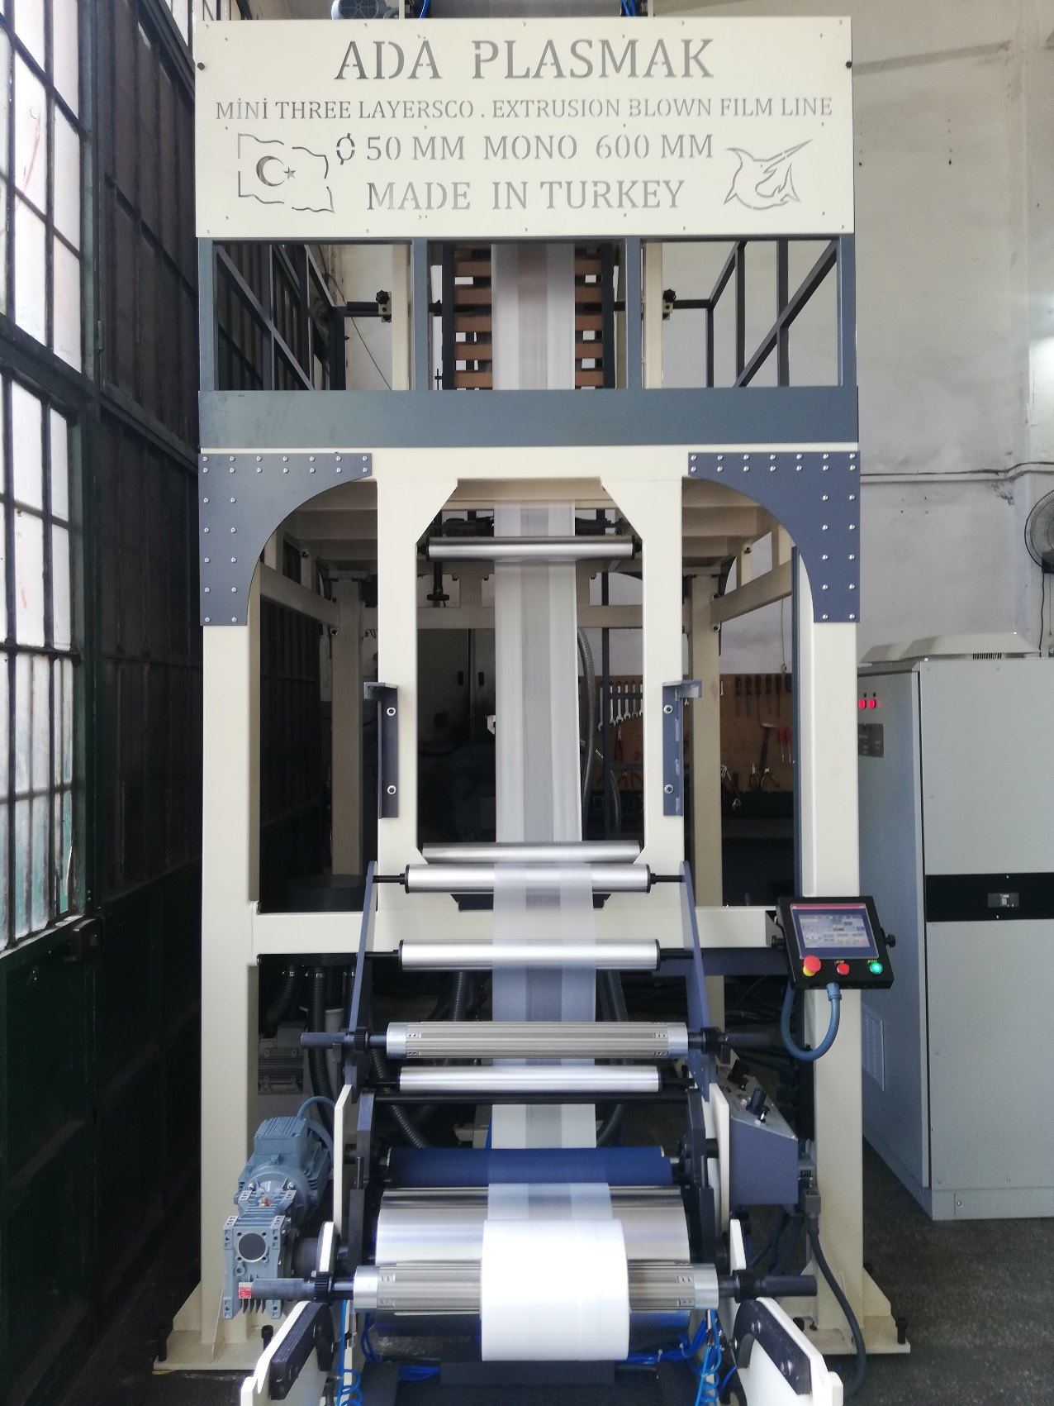

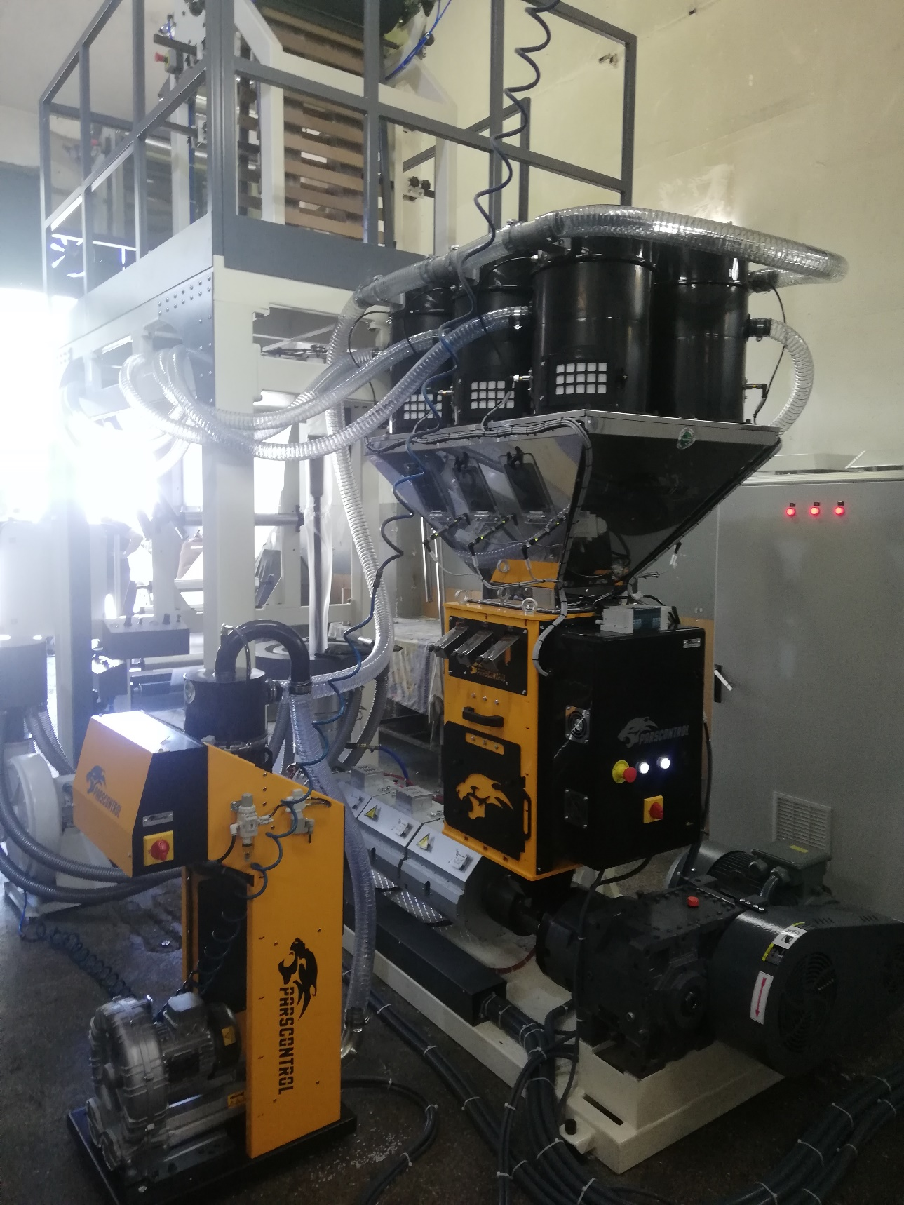

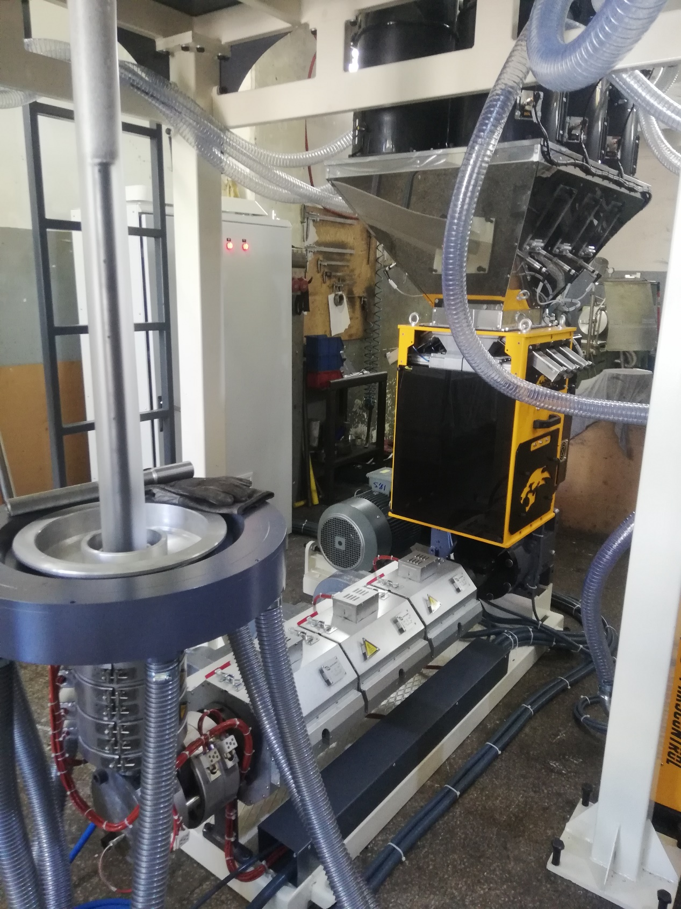

QNT. | DESCRIPTION | PRICE
1 | APM Ø50 HDPE MONO FILM MACHINE | USD
 | TOTAL PRICE | USD

1.COMMERCIAL TERMS AND CONDITION & PAYMENT TERMS
VAT is not included our offer.
40% down payment upon receipt of the order confirmation
60% of the order value before shipment by TT

2.DELIVERY TERMS
The total price is EXW Adaplasmak Factory (according to INCOTERMS, 2010 edition)

3. SHIPMENT TIME
Shipment will be made approximately ... days (10 days optional) after receiving the down payment. The actual shipping date will be confirmed after your down payment is received.
In case of delay in shipment due to reasons beyond the control of Adaplasmak Plastik Makine, transportation, storage and warehouse fees to the appropriate warehouse place belong to the buyer.

4.SUPERVISION OF INSTALLATION AND COMISSIONING
Commissioning can be conducted by our trained personnel at the agreed time. The costs for the travel to and from the site, accommodation and expenses are belong to the buyer.
The buyer should supply personnel for the installation.

5.WARRANTY
We warranty for a period year (one year) following the shipping documents date of issue.
The warranty does not extend normal wear and tear, damages based on incorrect use, unsuitable operation, unsuitable facilities and chemicals.

6.VALIDITY OF THE OFFER
This quotation valid 1 month after the quotation date.

Bank Details : Garati Bankası /İkitelli Siteler Branch.(USD)
Iban:TR45 006 2001 4400 0009 096743
Receiver Name: ADAPLASMAK PLASTİK MAKİNE SAN.TİC ŞTİ

