Date:
OFFER No:
OFFER
 | Company : | Responsible:
 | Tel: | Fax: |  | E-mail:
 | Address:
45x55 ABA EXTRUDER 900 MM
GENERAL FEATURES
MACHINE CODE |  |  | APM 45X55 ABA
TOWER |  |  | FIXED TOWER 5000 MM SINGLE FLOOR
SCREW DIA |  |  | A-45-B50 MM BARRIER
MAX. CAPACITY |  |  | 115 KG DEPEND ON MATERIAL
MAX FILM WIDTH |  |  | 850 MM
MIN.FILM WIDTH |  |  | 200 MM
MAX.FILM THICKNESS |  |  | SINGLE LAYER 200 MICRON
MIN.FILM THICKNESS |  |  | SINGLE LAYER 30 MICRON
MAX. TOTAL POWER(MAX) |  |  | 55 KW
DIE HEAD DIAMETER |  |  | 85 MM
DIE HEAD TYPE |  |  | A-B-A INTERWINDE SPIRAL
DIE HEAD SYSTEM |  |  | FIXED
DIE HEAD MATERIAL |  |  | 4140 NITRITED STEEL
EMBOSSING ROLLER |  |  | EXIST 1-2
AIR SHAFT |  |  | EXIST
BALLOON CAGE |  |  | EXIST
BANANA ROLLER |  |  | EXIST WITH REDUCER
CORONA |  |  | OPTIONAL
DOSING |  |  | OPTIONAL
SPARE DIE HEAD |  |  | OPTIONAL
ROTATING TOWER |  |  | OPTIONAL
RAW MATERIAL LOADER |  |  | OPTIONAL
KNIFE SYSTEM |  |  | OPTIONAL
DOUBLE WINDER UNIT |  |  | OPTIONAL
AUTOMATIC WINDER |  |  | OPTIONAL

TECHNICAL SPECIFICATIONS

REDUCER | HTE-322 HS-422 YILMAZ BRAND
SCREW MATERIAL | 1.8550 NITRITED STEEL
BARREL MATERIAL | 1.8550 GERMAN STEEL
BARREL DIAMETER | Ø45 Ø60(2 D) (32 D)
SCREW & BARREL PRODUCER | TURKISH SENMAK BRAND
BALLOON COOLING SYSTEM | FIXED 6 INPUT
UPPER ROLLER | Ø214 MM MITRIL RUBBER ROLLER
WINDER ROLLER | Ø270 MM STEEL
WINDER TYPE | SINGLE MANUAL WINDER
FILTER SYSTEM | MANUEL ROCKET SYSTEM Ø75 MM

ELECTRICAL SPECIFICATIONS
ROTATING DIE MOTOR | DOES NOT EXIST
BALLOON COOLING MOTOR | 3 KW 1500 D/D
BALLOON COOLING INVERTER | 3 KW ABB ACS
BALLOON COOLING FAN | ALUMINIUM BODY
A MAIN MOTOR | 18,5 KW 1500 D/D
A MAIN MOTOR INVERTER | 18,5 KW ABB 1500 D/D
B MAIN MOTOR | 30 KW GAMAK
B MAIN MOTOR INVERTER | 30 KW ABB ACS
UP PULLER MOTOR | 1,5 KW 1500 D/D
UP PULLER INVERTER | 1,5 KW ABB ACS
BARREL COOLING | 0,75 KW 3 PCS BARREL FAN
RESISTANCES | CERAMIC
WINDER MOTOR | 1,5 KW 1500 D/D
WINDER MOTOR INVERTER | 1,5 KW ABB ACS
MAIN ELECTRIC PANEL | ABB BRAND AND INVERTER MATERIALS AND ABB 10 TOUCH SCREEN 'GENCLER ELECTRIC' SYSTEM WILL BE MADE BY 'GENCLER ELECTRIC'.

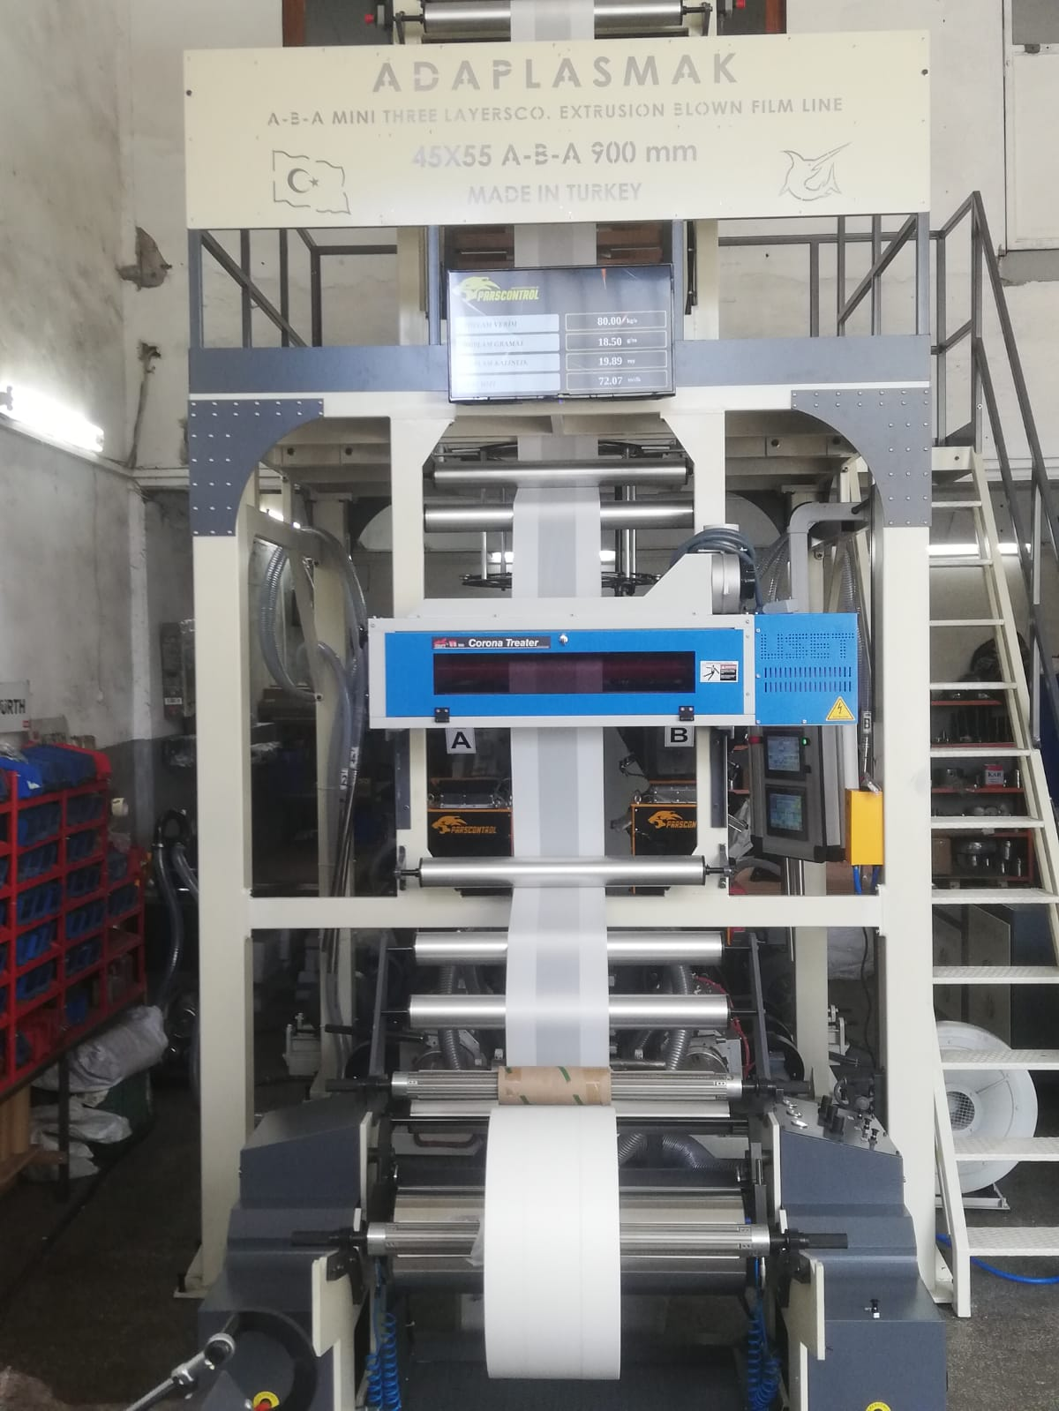

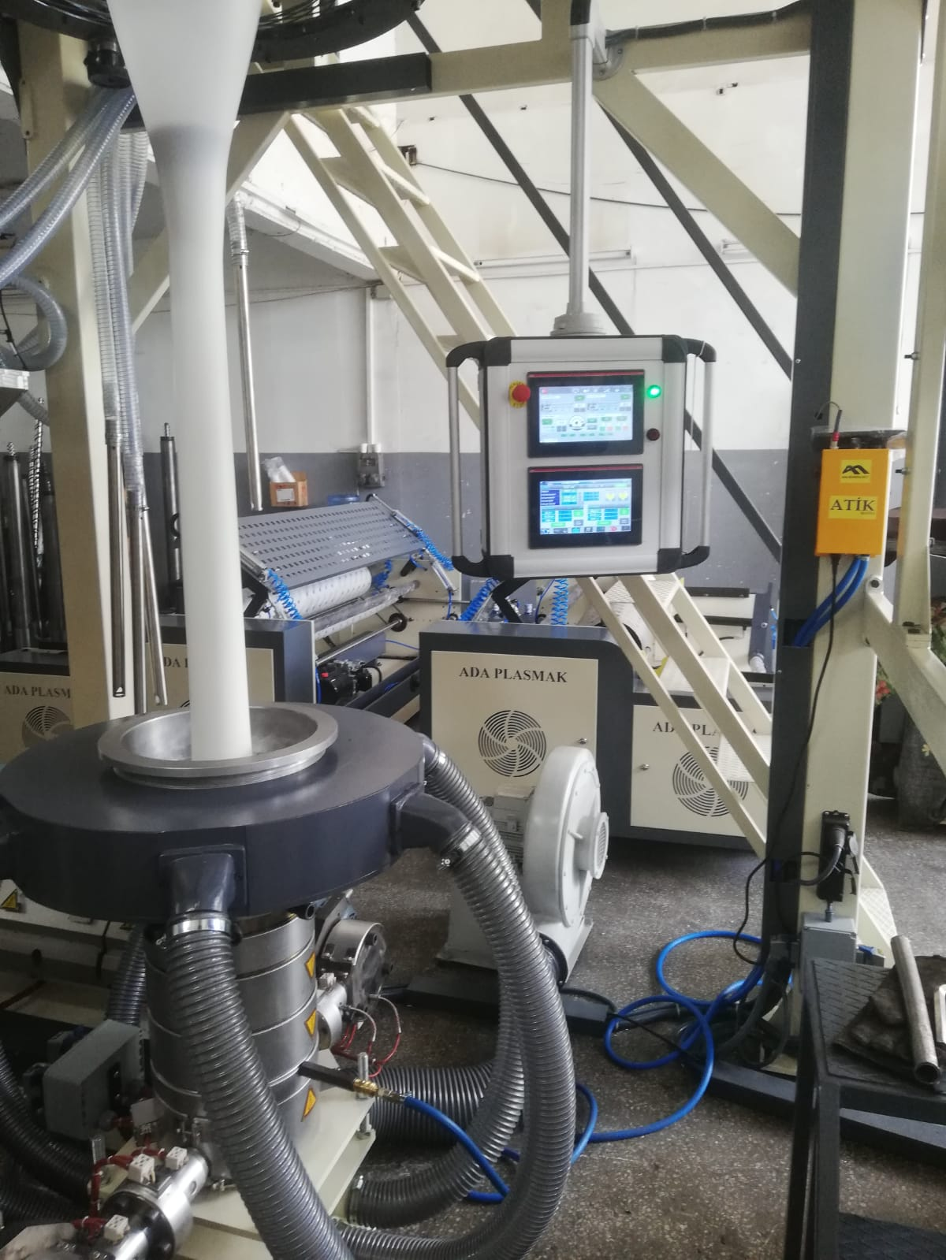

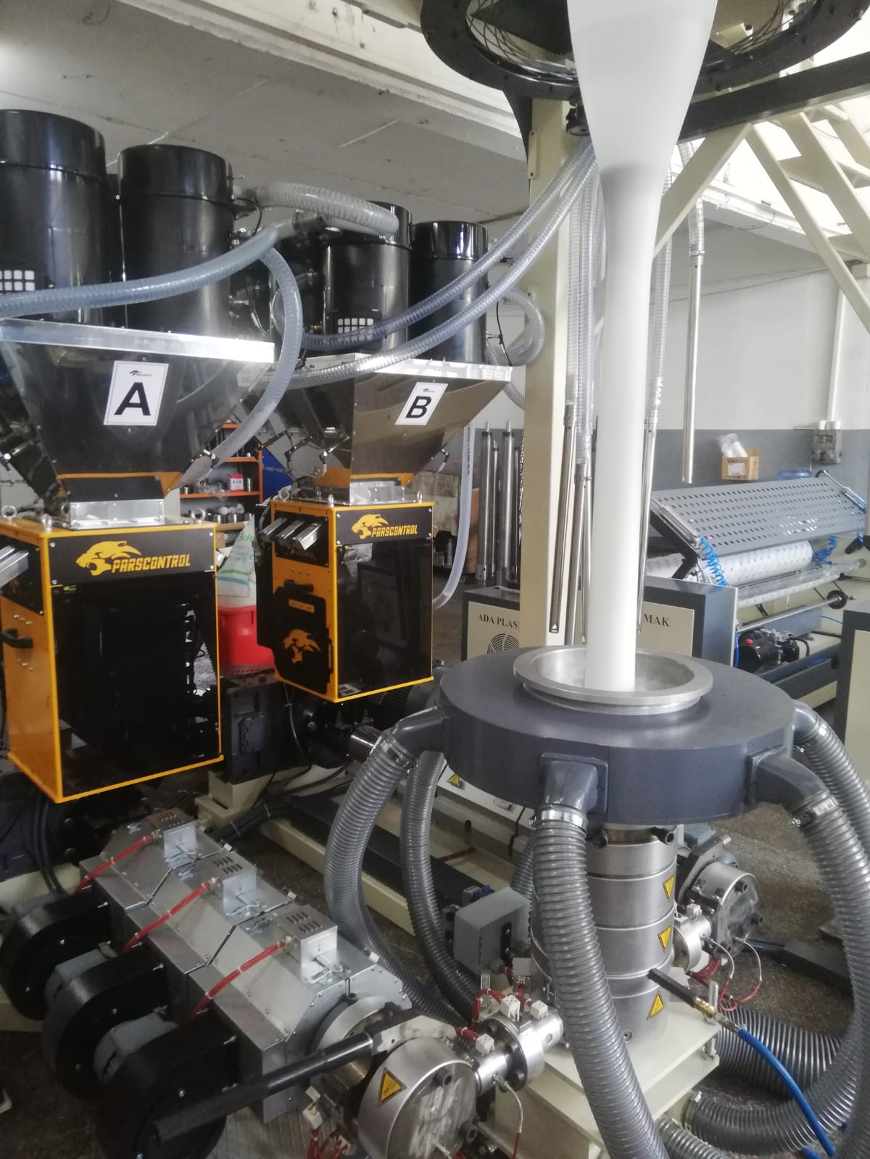

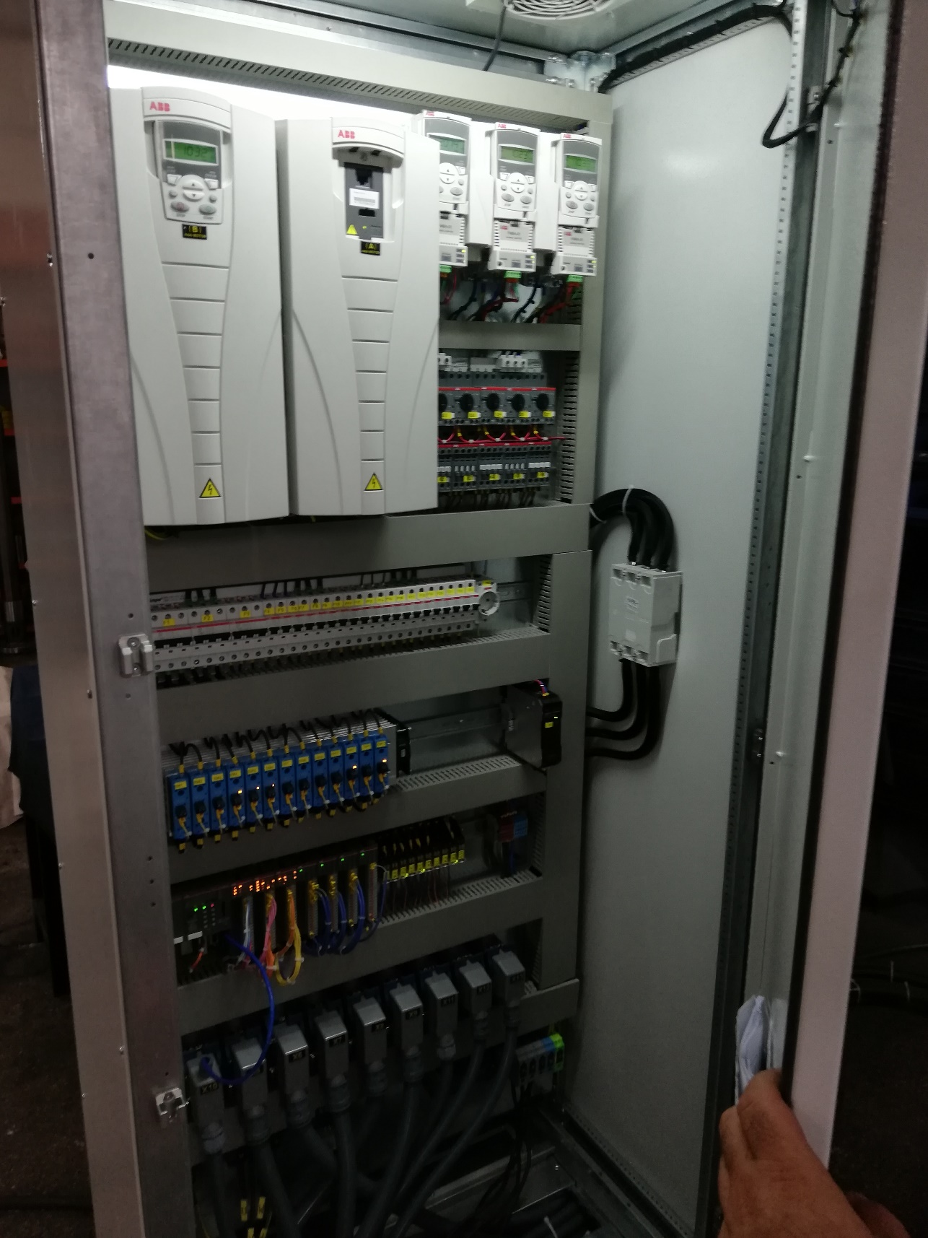

QNT. | DESCRIPTION | PRICE
1 | APM Ø45*55 ABA 900 FILM MACHINE | USD
 | TOTAL PRICE

1.COMMERCIAL TERMS AND CONDITION & PAYMENT TERMS
VAT is not included our offer.

40% down payment upon receipt of the order confirmation
60% of the order value before shipment by TT

2.DELIVERY TERMS
The total price is EXW Adaplasmak Factory (according to INCOTERMS, 2010 edition)

3. SHIPMENT TIME
Shipment will be made approximately 100 days (10 days optional) after receiving the down payment. The actual shipping date will be confirmed after your down payment is received.
In case of delay in shipment due to reasons beyond the control of Adaplasmak Plastik Makine, transportation, storage and warehouse fees to the appropriate warehouse place belong to the buyer.

4.SUPERVISION OF INSTALLATION AND COMISSIONING
Commissioning can be conducted by our trained personnel at the agreed time. The costs for the travel to and from the site, accommodation and expenses are belong to the buyer.
The buyer should supply personnel for the installation.

5.WARRANTY
We warranty for a period year (one year) following the shipping documents date of issue.
The warranty does not extend normal wear and tear, damages based on incorrect use, unsuitable operation, unsuitable facilities and chemicals.

6.VALIDITY OF THE OFFER
This quotation valid 1 month after the quotation date.

Bank Details : Garati Bankası /İkitelli Siteler Branch.(USD)
Iban:TR45 006 2001 4400 0009 096743
Receiver Name: ADAPLASMAK PLASTİK MAKİNE SAN.TİC ŞTİ

