Date:
Offer No:
OFFER
 | Company: | Responsible:
 | Tel: | Fax: |  | E-mail:
 | Address:
50X60 ABA EXTRUDER 1100 MM
GENERAL FEATURES
MACHINE CODE |  |  | APM 50X60 ABA
TOWER |  |  | FIXED TOWER 5500 MM SINGLE LAYER
SCREW DIA |  |  | A-50-B60 MM BARRIER
MAX. CAPACITY |  |  | 130 KG DEPEND ON MATERIAL
MAX FILM WIDTH |  |  | 1050 MM
MIN.FILM WIDTH |  |  | 300 MM
MAX.FILM THICKNESS |  |  | SINGLE LAYER 200 MICRON
MIN.FILM THICKNESS |  |  | SINGLE LAYER 30 MICRON
MAX. TOTAL POWER(MAX) |  |  | 67 KW
DIE HEAD DIAMETER |  |  | 100 MM
DIE HEAD TYPE |  |  | A-B-A
DIE HEAD SYSTEM |  |  | FIXED OZGULMAK BRAND
DIE HEAD MATERIAL |  |  | 4140 NITRITED STEEL
EMBOSSING ROLLER |  |  | EXIST 1-2 TEETH
AIR SHAFT |  |  | EXIST
BALLOON CAGE |  |  | EXIST AUTOMATIC
BANANA ROLLER |  |  | EXIST
CORONA |  |  | OPTIONAL
DOSING |  |  | OPTIONAL
SPARE DIE HEAD |  |  | OPTIONAL
ROTATING TOWER |  |  | OPTIONAL
RAW MATERIAL LOADER |  |  | OPTIONAL
KNIFE SYSTEM |  |  | OPTIONAL
DOUBLE WINDING UNIT |  |  | OPTIONAL
AUTOMATIC WINDING |  |  | OPTIONAL

TECHNICAL SPECIFICATIONS

REDUCER | HS-322 HS 522 YILMAZ BRAND
SCREW MATERIAL | 1.8550 GERMAN STEEL
BARREL MATERIAL | 1.8550 GERMAN STEEL
BARREL DIAMETER | 50X60
SCREW & BARREL PRODUCER | TURKISH SENMAK BRAND
BALLOON COOLING SYSTEM | FIXED 6 ENTER
UPPER ROLLER | Ø214 MM LASTIC STEEL
WINDING ROLLER | Ø270 MM STEEL
WINDING TYPE | SINGLE WINDER
FILTER SYSTEM | MANUAL ROCKET SYSTEM Ø95 MM

MACHINE ELECTRICAL SPECIFICATIONS
ROTATING DIE MOTOR | -
BALLOON COOLING MOTOR | 3 kW GAMAK
BALLOON COOLING DRIVER | 3 kW ABB
BALLOON COOLING FAN | ALUMINIUM BODY
A MAIN MOTOR | 37 KW GAMAK
A MAIN MOTOR DRIVER | 37 KW ABB
B MAIN MOTOR | 30 KW GAMAK
B MAIN MOTOR DRIVER | 30 KW ABB ACS
UP PULLER MOTOR | 1,5 KW GAMAK
UP PULLER DRIVER | 1,5 KW ABB
BARREL COOLING | 0,75 KW 3 PCS BARREL
RESISTANCES | CERAMIC
WINDING MOTOR | 1,5 KW GAMAK
WINDING MOTOR DRIVER | 1,5 KW ABB
MAIN ELECTRIC PANEL | ABB BRAND AND INVERTER MATERIALS AND ABB 10 TOUCH SCREEN 'GENCLER ELECTRIC' SYSTEM WILL BE MADE BY 'GENCLER ELECTRIC'.

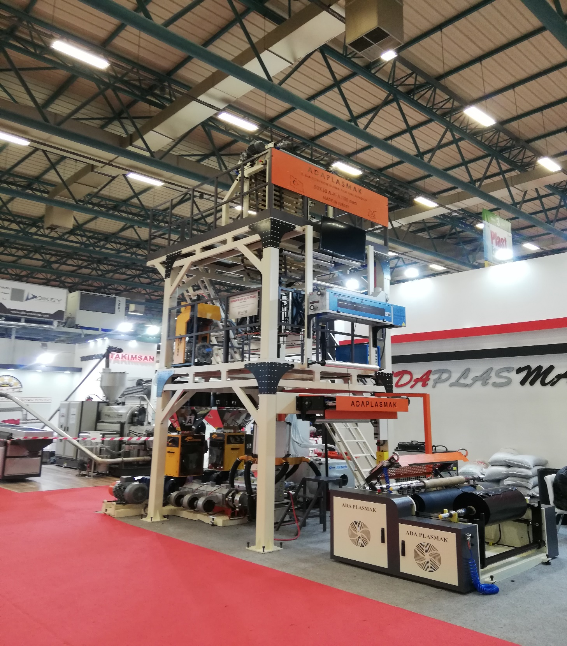

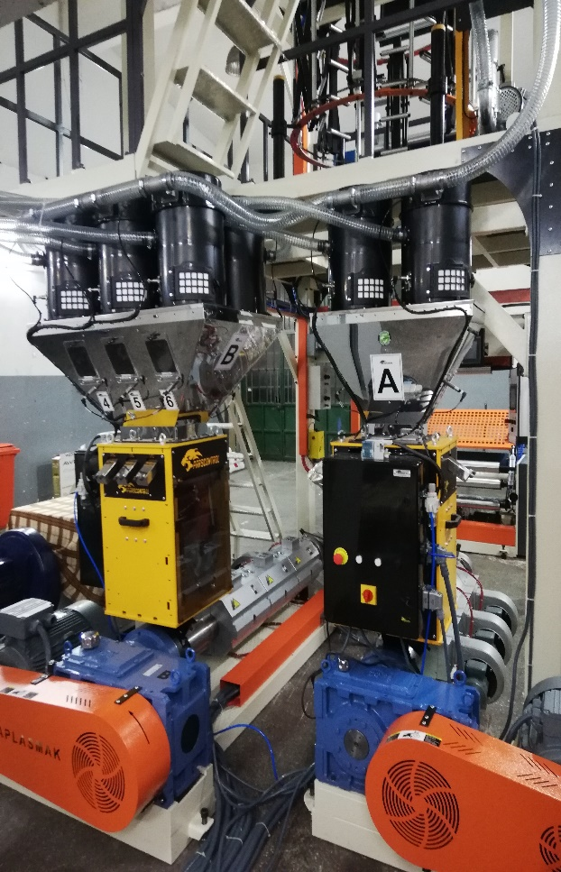
QNT | DESCRIPTION | PRICE
1 | APM Ø50X60 ABA EXTRUDER FILM MACHINE FIXED TOWER FIXED DIE HEAD 1100 MM | USD
 | TOTAL PRICE | USD

1.COMMERCIAL TERMS AND CONDITION & PAYMENT TERMS
VAT is not included our offer.

40% down payment upon receipt of the order confirmation
60% of the order value before shipment by TT

2.DELIVERY TERMS
The total price is EXW Adaplasmak Factory (according to INCOTERMS, 2010 edition)

3. SHIPMENT TIME
Shipment will be made approximately 100 days (10 days optional) after receiving the down payment. The actual shipping date will be confirmed after your down payment is received.
In case of delay in shipment due to reasons beyond the control of Adaplasmak Plastik Makine, transportation, storage and warehouse fees to the appropriate warehouse place belong to the buyer.

4.SUPERVISION OF INSTALLATION AND COMISSIONING
Commissioning can be conducted by our trained personnel at the agreed time. The costs for the travel to and from the site, accommodation and expenses are belong to the buyer.
The buyer should supply personnel for the installation.

5.WARRANTY
We warranty for a period year (one year) following the shipping documents date of issue.
The warranty does not extend normal wear and tear, damages based on incorrect use, unsuitable operation, unsuitable facilities and chemicals.

6.VALIDITY OF THE OFFER
This quotation valid 1 month after the quotation date.

Bank Details : Garati Bankası /İkitelli Siteler Branch.(USD)
Iban:TR45 006 2001 4400 0009 096743
Receiver Name: ADAPLASMAK PLASTİK MAKİNE SAN.TİC ŞTİ

