Date:
Offer No:
OFFER
 | Company: | Responsible:
 | Tel: | Fax: |  | E-mail:
 | Address:
60x70 ABA 1300 MM EXTRUDER FILM MACHINE
GENERAL SPECIFICATIONS OF MACHINE
MODEL NAME |  |  | APM 60x70 ABA
TOWER |  |  | FIXED TOWER 7000 MM DOUBLE LAYER
SCREW DIAMETER |  |  | A-60MM- B-70MM
MAXIMUM CAPACITY |  |  | 180 KG (It depends on product)
MAX FILM WIDTH |  |  | 1250 MM
MINIMUM FILM WIDTH |  |  | 400 MM
MAX. FILM THICKNESS |  |  | SINGLE LAYER 200 MICRON
MIN. FILM THICKNESS |  |  | SINGLE LAYER 30 MICRON
MAX.TOTAL ELECTRICAL POWER (MAX) |  |  | 70 kW
HEAD DIAMETER OF OUTPUT |  |  | Ø 140 MM
DIE HEAD TYPE |  |  | A-B-A
DIE HEAD SYSTEM |  |  | FIXED HEAD
DIE HEAD MATERIAL |  |  | 4140 NITRATED STEEL
COFRAJ ROLLER |  |  | EXIST
AIR SHAFT |  |  | EXIST
BALLOON CAGE |  |  | EXIST AUTOMATIC
BANANA ROLLER |  |  | EXIST
CORONA TREATMENT |  |  | OPTIONAL
DOSING UNIT |  |  | OPTIONAL
SPARE DIE HEAD |  |  | OPTIONAL
ROTATING TOWER |  |  | OPTIONAL
AUTOMATIC ABSORBENT |  |  | OPTIONAL
KNIFE SYSTEM |  |  | OPTIONAL
DOUBLE WINDING UNIT |  |  | OPTIONAL
AUTOMATIC WINDER |  |  | OPTIONAL

TECHNICAL DETAILS OF MACHINE

REDUCTOR | HTE 522 HTE622 ‘YILMAZ’ BRAND
SCREW MATERIAL | 1.8550 GERMAN STEEL
BARREL MATERIAL | 1.8550 GERMAN STEEL
BARREL DIMENSION | 60x70
SCREW&BARREL PRODUCER | TURKEY SENMAK BRAND
BALLOON COOLING SYSTEM | FIXED 6 INPUT
UPPER WINDER ROLLER | Ø214 MM RUBBER
WINDER ROLLER | Ø270 MM METAL
WINDER UNIT | SINGLE WINDER MANUEL
FILTER SYSTEM | MANUEL ROCKET SYSTEM Ø100 MM

ELECTRICAL DETAILS OF MACHINE
ROTATION HEAD MOTOR
BALLOON COOLING MOTOR | 5,5 KW GAMAK
BALLOON COOLING INVERTER | 5,5 KW ABB
BALLOON COOLING FAN | ALUMINIUM CHASSIS
A MAIN MOTOR | 45 KW GAMAK
A MAIN MOTOR INVERTER | 45 KW GAMAK
B MAIN MOTOR | 37 kW GAMAK
B MAIN MOTOR INVERTER | 37 kW ABB
TAKE OFF MOTOR | 1,5 KW GAMAK
TAKE OFF UNIT INVERTER | 1,5 KW ABB
BARREL COOLING | 0,75 KW 3 PCS BARREL
RESISTANCE TYPE | CERAMIC
WINDER MOTOR | 1,5 KW GAMAK
WINDER INVERTER | 1,5 KW ABB
MAIN POWER PANEL | ABB BRAND ALL ELECTRICAL COMPONENTS EQUIPED WITH ABB 10 INCH TOUCH SCREEN AND ALL AUTOMATION SYSTEM WILL BE MADE BY ‘GENCLER ELECTRONICS’

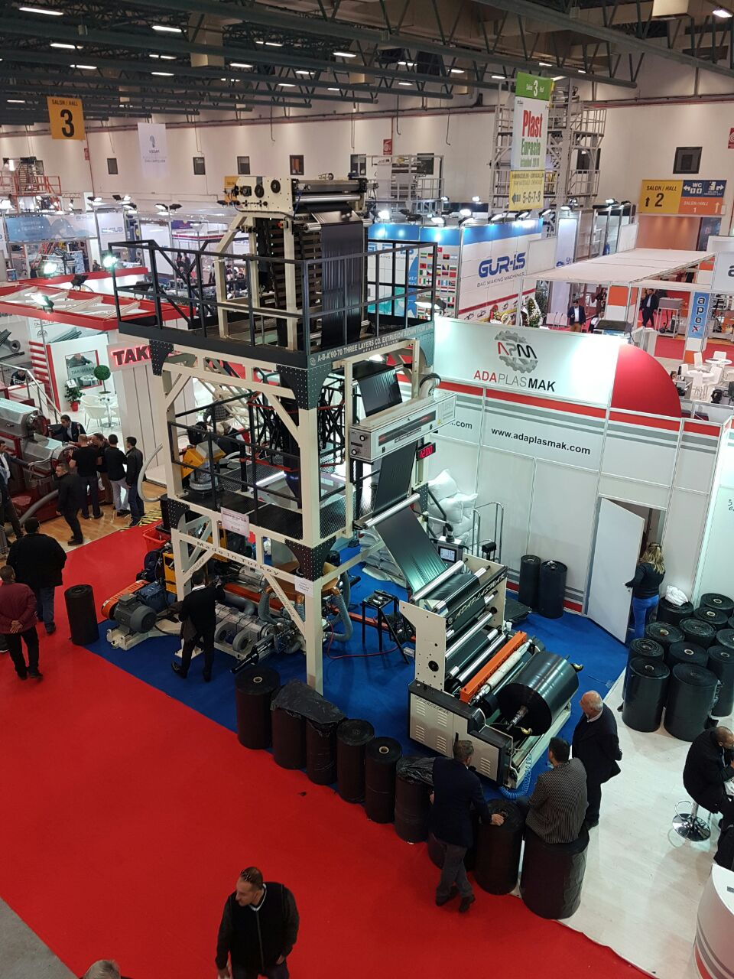
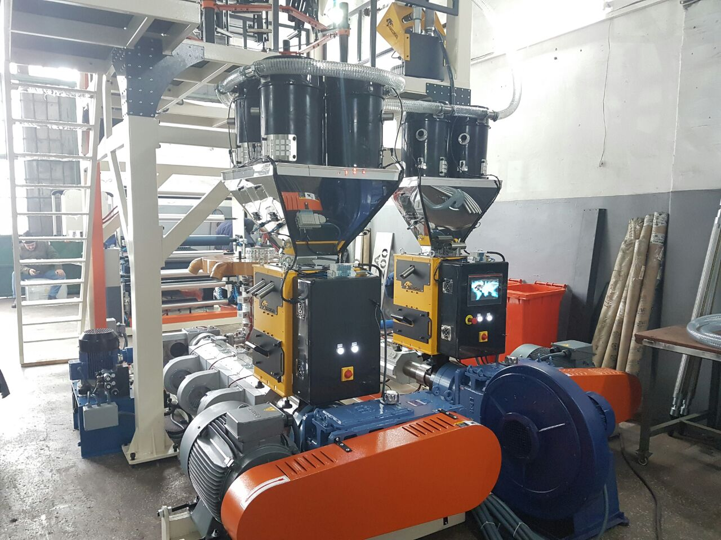

QNT. | DESCRIPTION | PRICE
1 | APM Ø60x70 ABA EXTRUDER FILM 130MM | USD
 | TOTAL PRICE | USD

1.COMMERCIAL TERMS AND CONDITION & PAYMENT TERMS
VAT is not included our offer.

40% down payment upon receipt of the order confirmation
60% of the order value before shipment by TT

2.DELIVERY TERMS
The total price is EXW Adaplasmak Factory (according to INCOTERMS, 2010 edition)

3. SHIPMENT TIME
Shipment will be made approximately 100 days (10 days optional) after receiving the down payment. The actual shipping date will be confirmed after your down payment is received.
In case of delay in shipment due to reasons beyond the control of Adaplasmak Plastik Makine, transportation, storage and warehouse fees to the appropriate warehouse place belong to the buyer.

4.SUPERVISION OF INSTALLATION AND COMISSIONING
Commissioning can be conducted by our trained personnel at the agreed time. The costs for the travel to and from the site, accommodation and expenses are belong to the buyer.
The buyer should supply personnel for the installation.

5.WARRANTY
We warranty for a period year (one year) following the shipping documents date of issue.
The warranty does not extend normal wear and tear, damages based on incorrect use, unsuitable operation, unsuitable facilities and chemicals.

6.VALIDITY OF THE OFFER
This quotation valid 1 month after the quotation date.

Bank Details : Garati Bankası /İkitelli Siteler Branch.(USD)
Iban:TR45 006 2001 4400 0009 096743
Receiver Name: ADAPLASMAK PLASTİK MAKİNE SAN.TİC ŞTİ

