Date:
Offer No:
OFFER
 | Company: | Responsible:
 | Tel: | Fax: |  | E-mail:
 | Address:
Ø70 HDPE EXTRUDER 1100 NONSTOP
FILM MACHINE
GENERAL SPECIFICATIONS OF MACHINE
MACHINE CODE |  |  | APM Ø70 HDPE
TOWER |  |  | FIXED TOWER 7000 MM DOUBLE LAYER
SCREW DIAMETER |  |  | Ø70 BARREL
MAX.CAPACITY |  |  | 180 KG
MAX. FILM WIDTH |  |  | 1050 mm
MIN FILM WIDTH |  |  | 250 mm
MAX. FILM THICKNESS
MIN. FILM THICKNESS
MAX. TOTAL ELECTRIC POWER |  |  | 60 KW
HEAD DIAMETER OUTPUT |  |  | 120 MM
HEAD TYPE |  |  | MONO
HEAD SYSTEM |  |  | ROTATION HEAD
HEAD MATERIAL |  |  | 4140 NITRITED STEEL
EMBOSSING ROLLER |  |  | EXIST
AIR SHAFT |  |  | EXIST
BALLOON CAGE |  |  | EXIST
BANANA ROLLER |  |  | EXIST WITH REDUCER
CORONA TREATMENT |  |  | OPTIONAL
DOSING UNIT |  |  | OPTIONAL
SPARE HEAD |  |  | OPTIONAL
ROTATION TOWER |  |  | OPTIONAL
AUTOMATIC ABSORMENT |  |  | OPTIONAL
KNIFE SYSTEM |  |  | OPTIONAL
DOUBLE WINDER UNIT |  |  | OPTIONAL
AUTOMATIC WINDER |  |  | OPTIONAL

TECHNICAL SPECIFICATIONS

REDUCER | HTE 722 YILMAZ BRAND
SCREW MATERIAL | 1.8550 GERMAN STEEL
BARREL MATERIAL | 1.8550 GERMAN STEEL
BARREL DIAMETER | Ø 70 BARREL
SCREW & BARREL PRODUCER | TURKISH SENMAK BRAND
BALLOON COOLING SYSTEM | FIXED 6 INPUT
UPPER ROLLER | Ø214 MM NITRILE RUBBER ROLLER
WINDER ROLLER | Ø270 MM STEEAL COATED RUBBER
WINDER TYPE | SINGLE WINDER MANUAL
FILTER SYSTEM | MANUEL ROCKET SYSTEM Ø120 MM

ELECTRICAL SPECIFICATIONS
ROTATION DIE MOTOR | 0,37 KW INVERTER
BALLOON COOLING MOTOR | 5,5 KW
BALLOON COOLING INVERTER | 5,5 KW ABB
BALLOON COOLING FAN | ALUMINIUM BODY
A MAIN MOTOR | 45 KW
A MAIN MOTOR INVERTER | 45 KW
B MAIN MOTOR
B MAIN MOTOR INVERTER
UP PULLER MOTOR | 1,5 KW GAMAK
UP PULLER INVERTER | 1,5 KW ABB
BARREL COOLING | 0,75 KW 2 PCS
RESISTANCE | CERAMIC
WINDER MOTOR | 1,5 KW GAMAK
WINDER INVERTER | 1,5 KW ABB
MAIN ELECTRIC PANEL | ABB BRAND AND INVERTER MATERIALS AND ABB 10 TOUCH SCREEN 'GENCLER ELECTRIC' SYSTEM WILL BE MADE BY 'GENCLER ELECTRIC'.
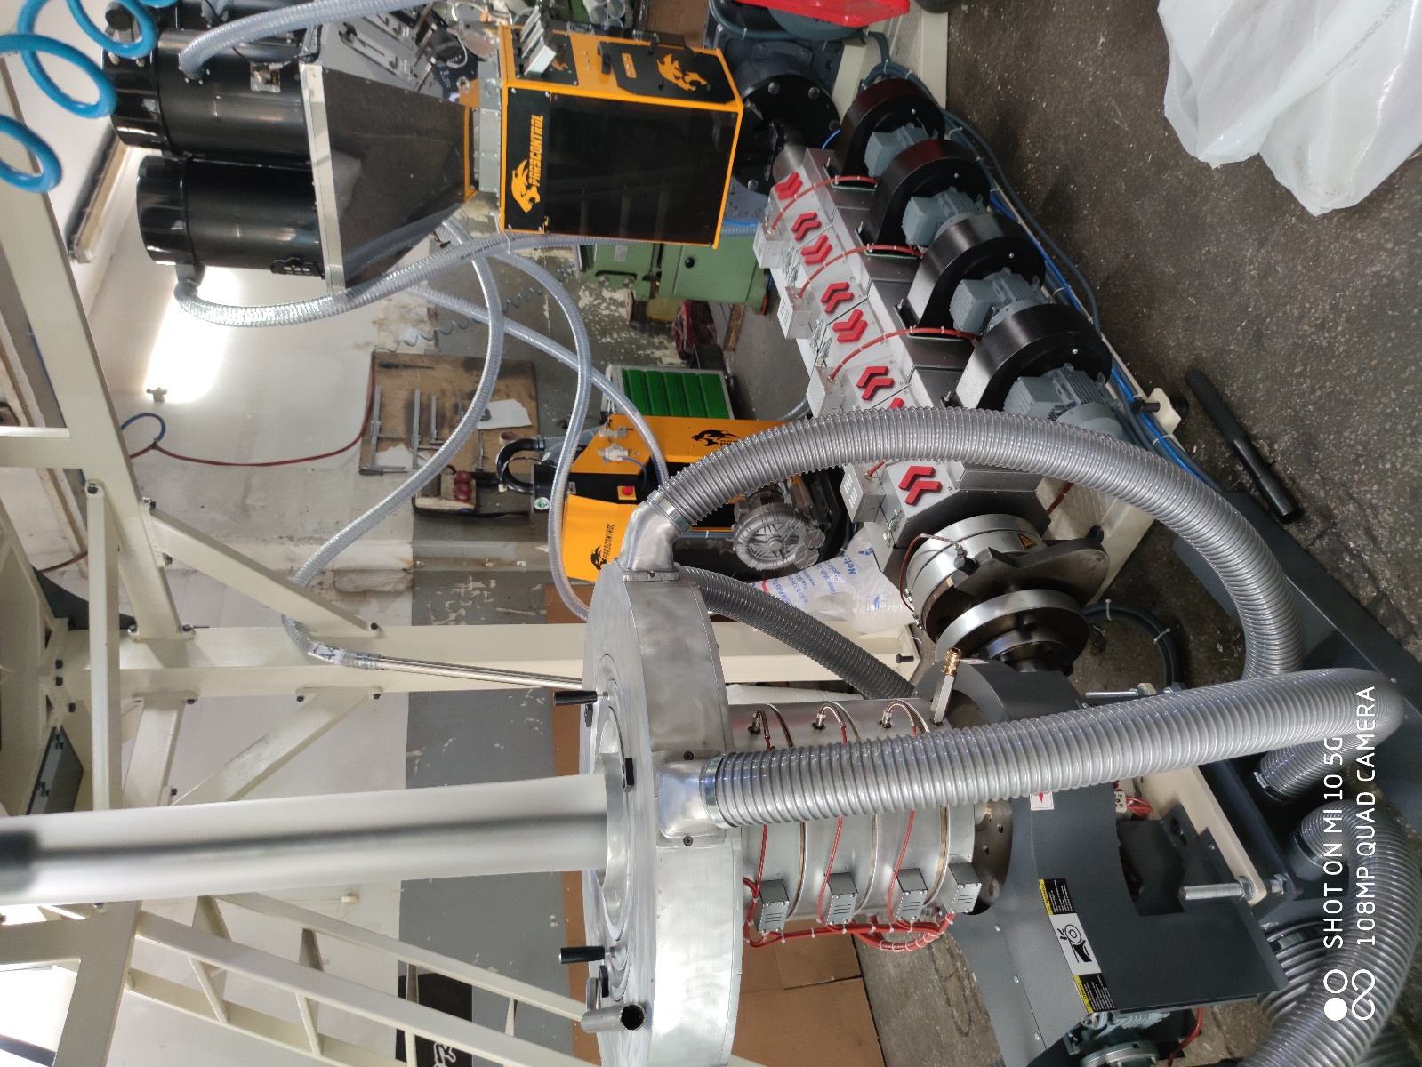
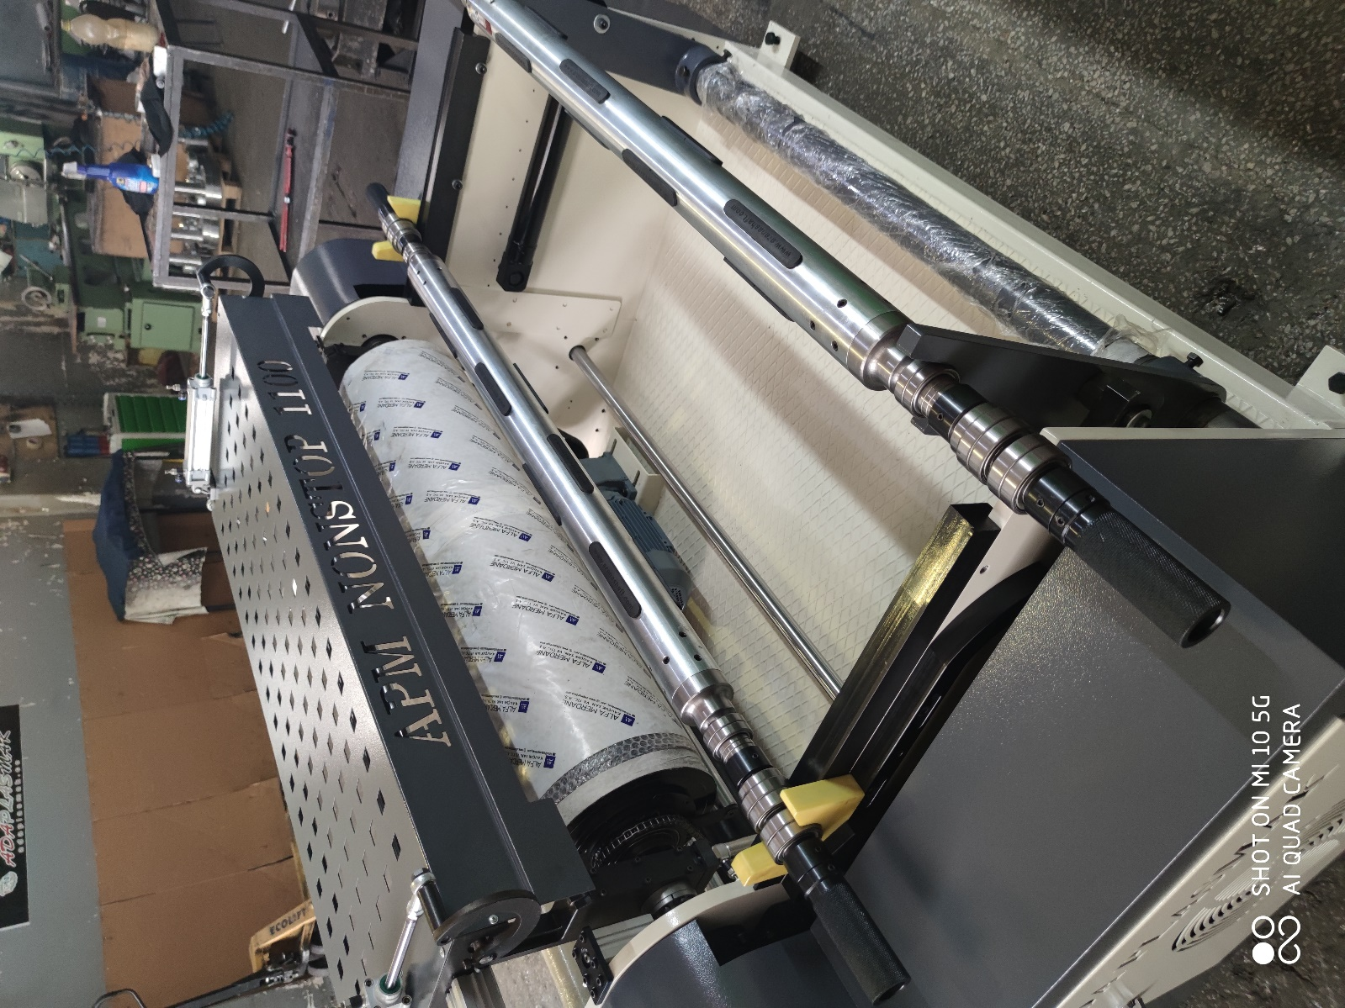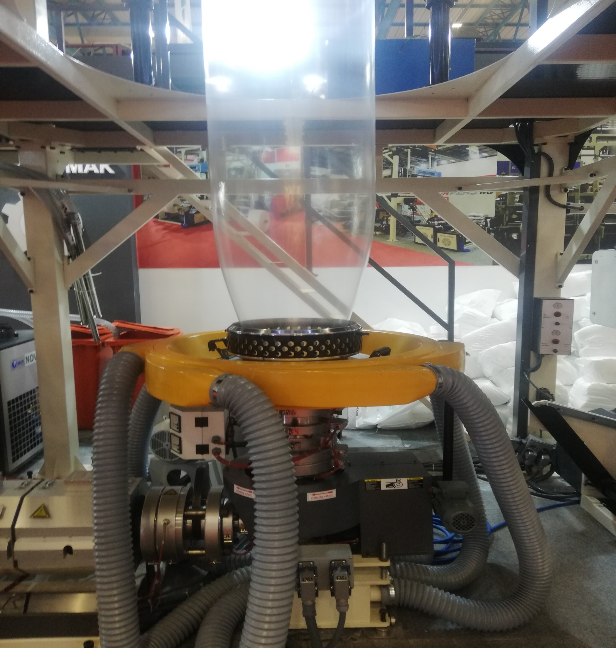
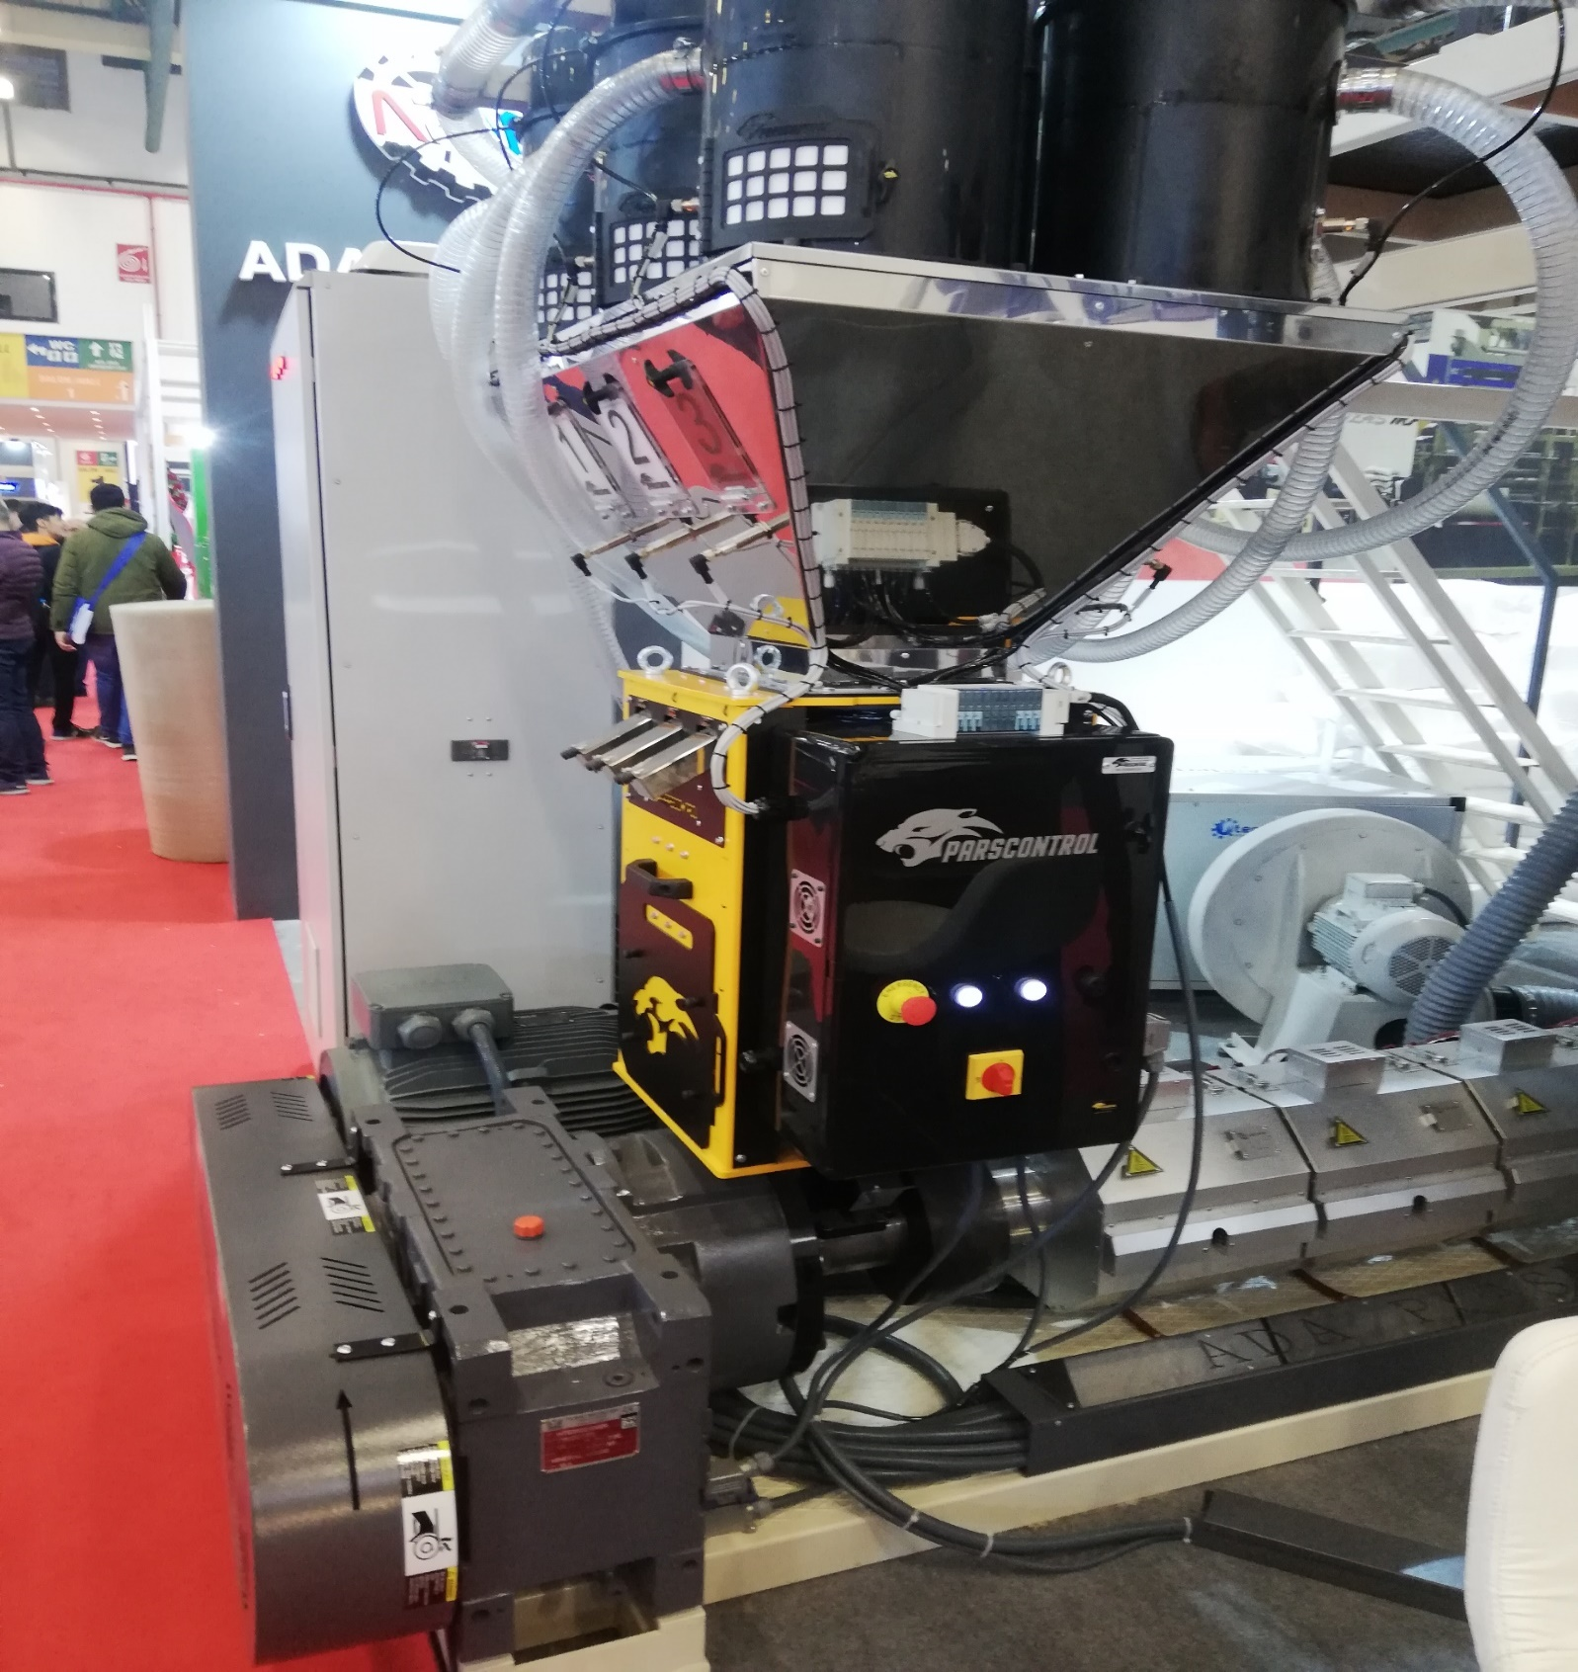
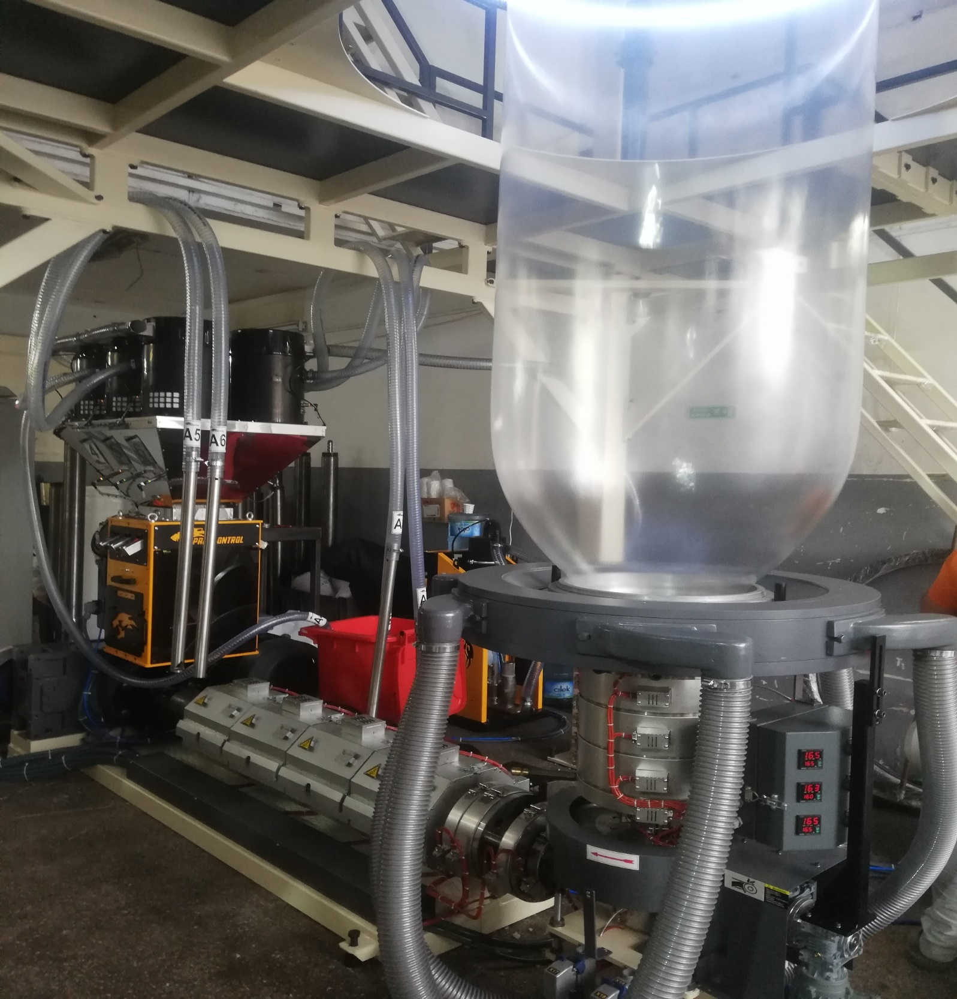
QNT. | DESCRIPTION | PRICE
1 | APM Ø70 HDPE 1100 NONSTOP | USD
 | TOTAL PRICE | USD

1.COMMERCIAL TERMS AND CONDITION & PAYMENT TERMS
VAT is not included our offer.

40% down payment upon receipt of the order confirmation
60% of the order value before shipment by TT

2.DELIVERY TERMS
The total price is EXW Adaplasmak Factory (according to INCOTERMS, 2010 edition)

3. SHIPMENT TIME
Shipment will be made approximately 100 days (10 days optional) after receiving the down payment. The actual shipping date will be confirmed after your down payment is received.
In case of delay in shipment due to reasons beyond the control of Adaplasmak Plastik Makine, transportation, storage and warehouse fees to the appropriate warehouse place belong to the buyer.

4.SUPERVISION OF INSTALLATION AND COMISSIONING
Commissioning can be conducted by our trained personnel at the agreed time. The costs for the travel to and from the site, accommodation and expenses are belong to the buyer.
The buyer should supply personnel for the installation.

5.WARRANTY
We warranty for a period year (one year) following the shipping documents date of issue.
The warranty does not extend normal wear and tear, damages based on incorrect use, unsuitable operation, unsuitable facilities and chemicals.

6.VALIDITY OF THE OFFER
This quotation valid 1 month after the quotation date.

Bank Details : Garati Bankası /İkitelli Siteler Branch.(USD)
Iban:TR45 006 2001 4400 0009 096743
Receiver Name: ADAPLASMAK PLASTİK MAKİNE SAN.TİC ŞTİ

